**TY B.Tech. (CSE) – II [ 2022-23 ]**

**5CS372 : Advanced Database System Lab.**

**Assignment No. 8  
  
2020BTECS00069**

**Yashraj Patil**

**1. Do the installation and configuration of Oracle/MySQL/IBM DB2**

**distributed databases. [ Take minimum 3 nodes ]**

**2. Use the above installed distributed database as backend for**

**Assignment No.3 & 4.**

**3. Demonstrate the working by connecting portals to different nodes,**

**adding data from one node and available / display on portal connected**

**to another node etc.**

**MySQL installation:**

**1)Install the setup for MySQL from MySQL** [**website**](https://dev.mysql.com/downloads/mysql/)**. Run the**

**setup.exe. Choose installation type as ‘Full’.**

**2) It will check whether your computer satisfies the necessary**

**requirements. Install the necessary requirements (select**

**requirements and click Execute) and click next. quirements and click Execute) and click next.**

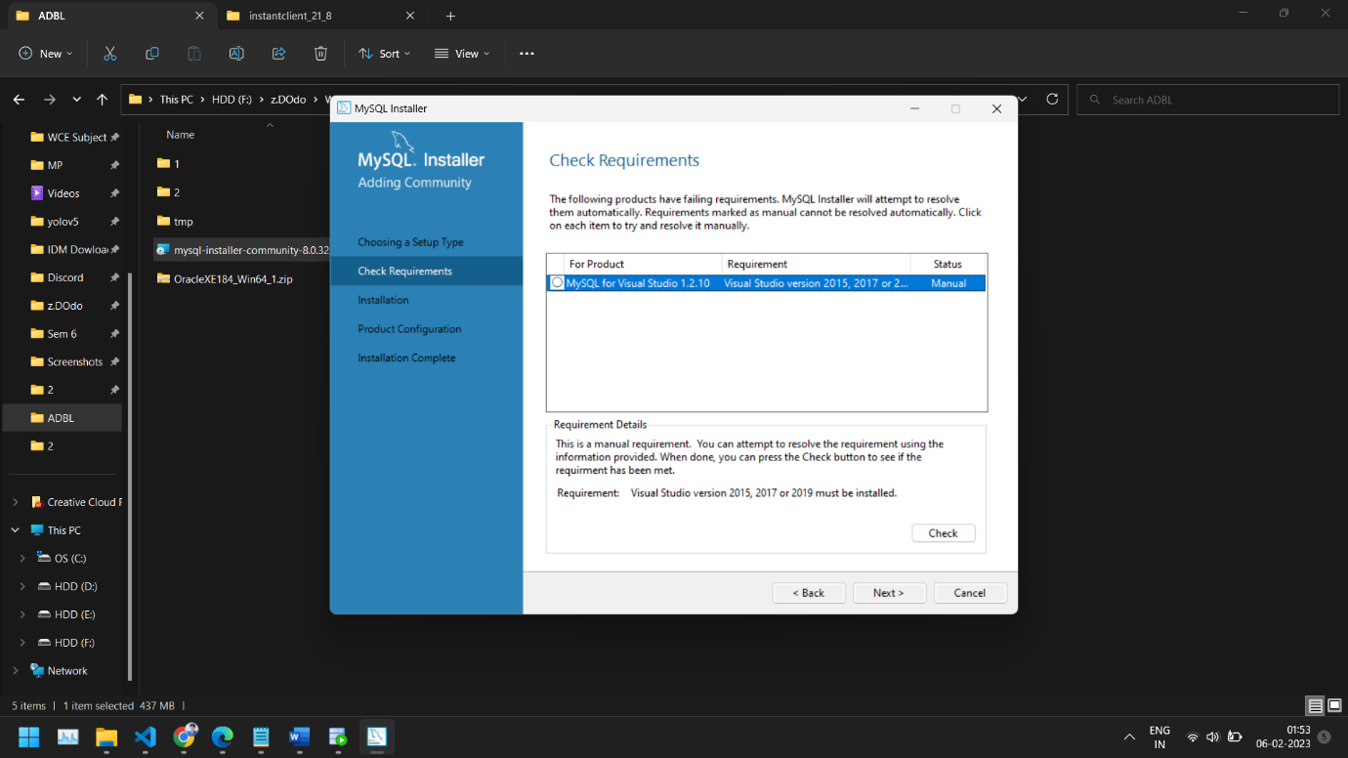

**3) Click execute to install the required setups.**

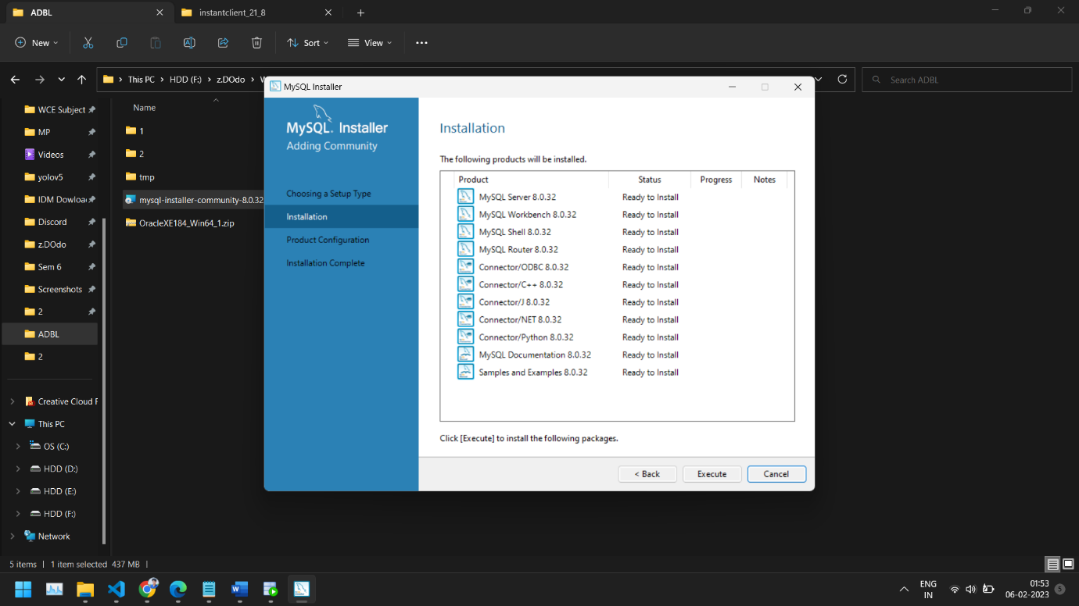

**4) Wait until all the files are installed.**

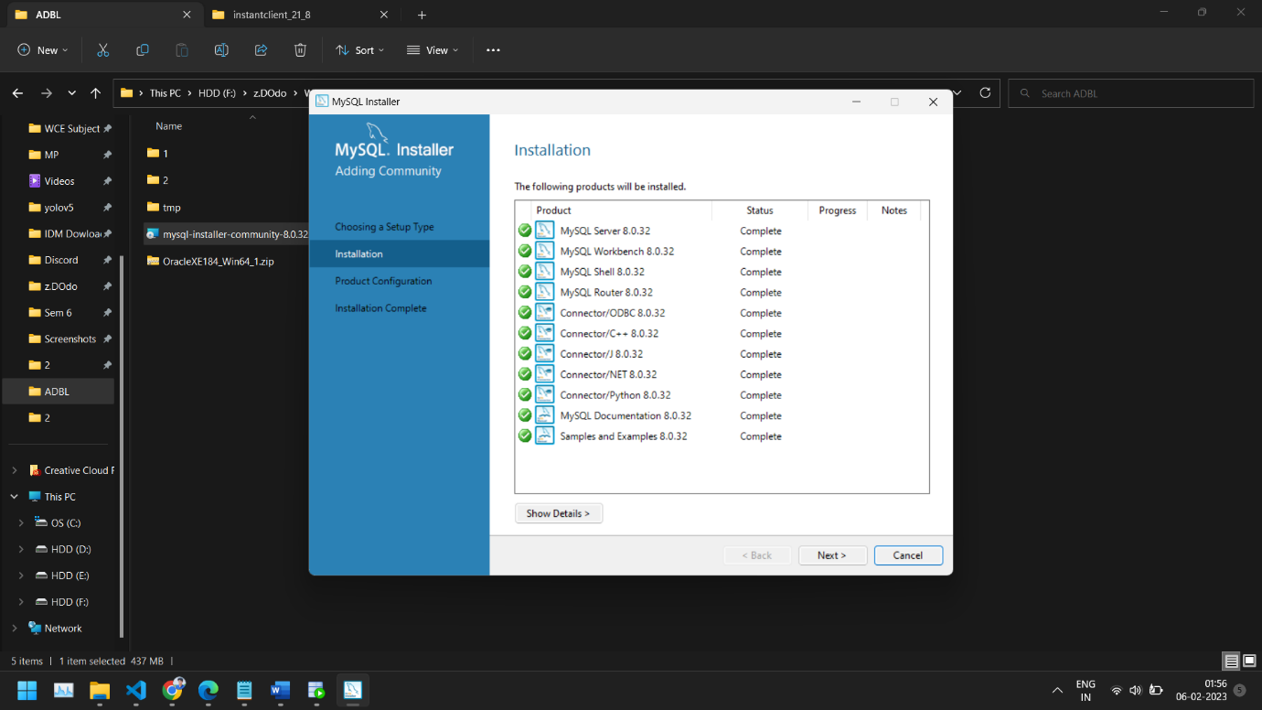

**5) Configure the product by clicking next.**

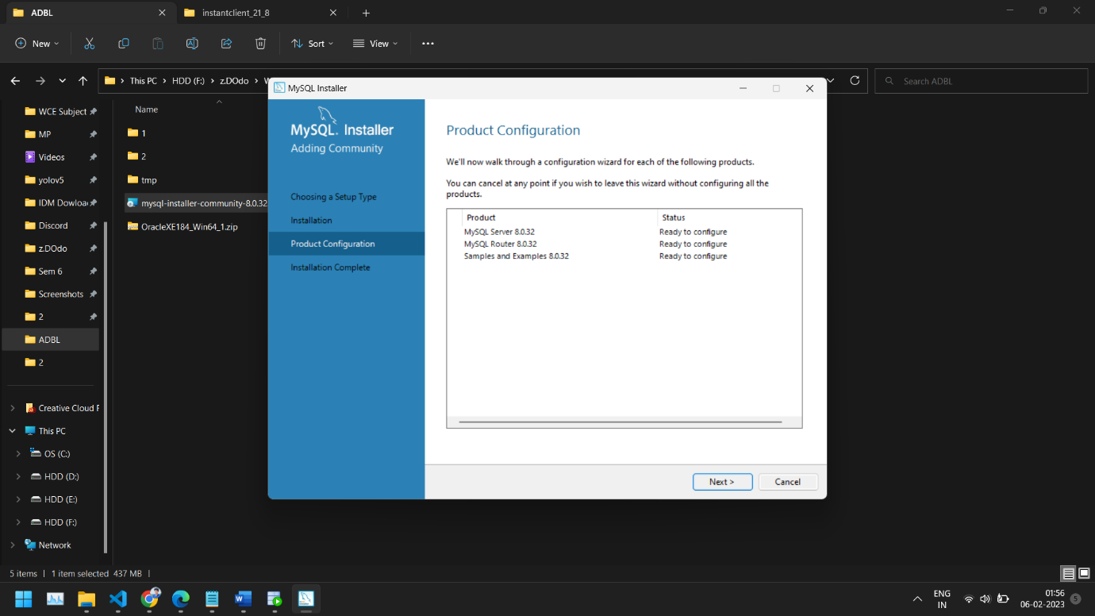

**6) Configure the network and click next.**

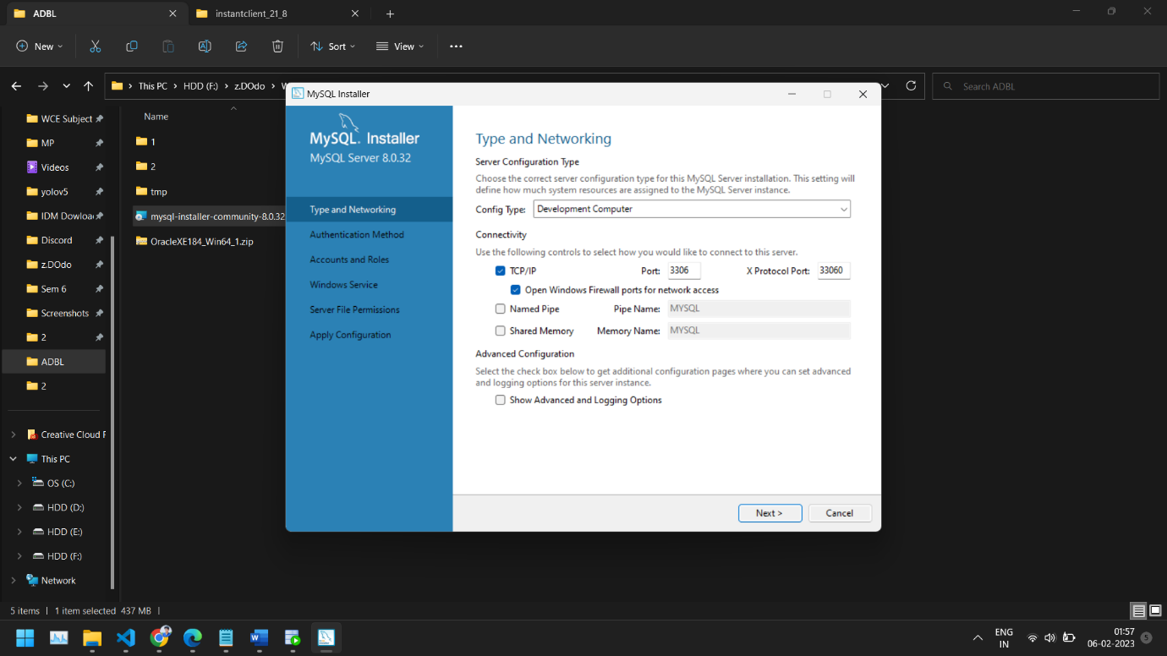

**7) Set the password for ‘root’ (admin) and click next.**

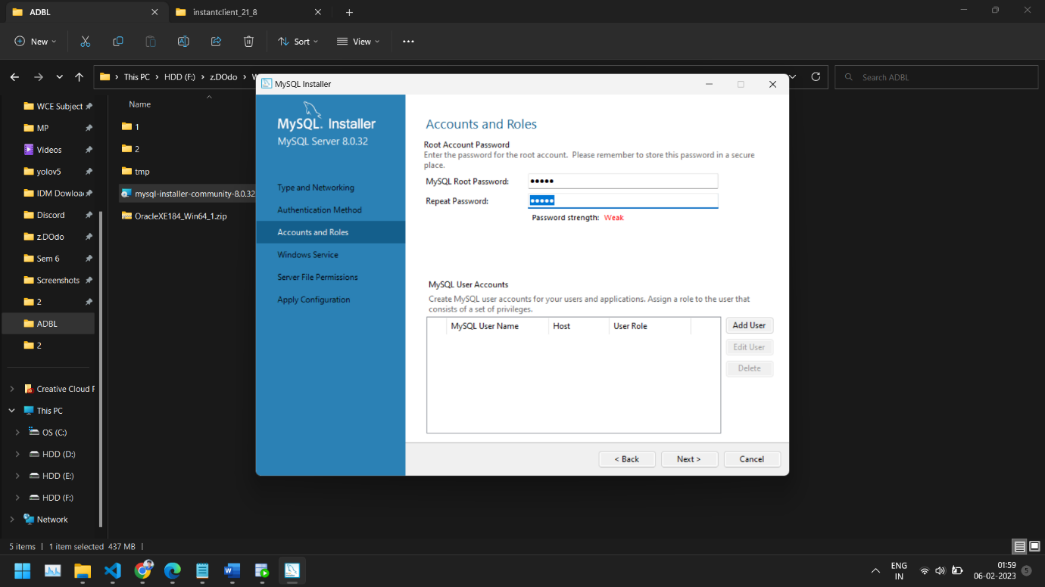

**8) Configure the windows service to start. Click next.**

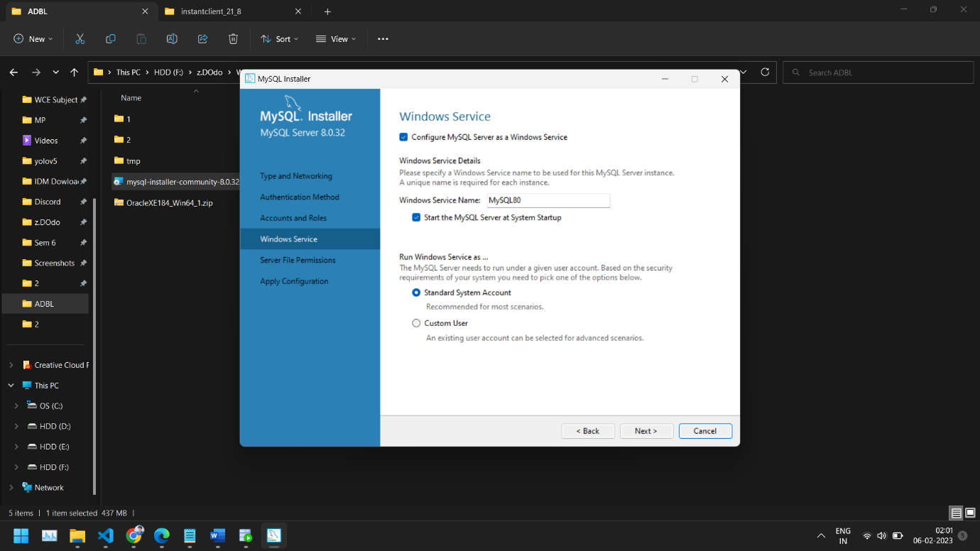

**9) Connect to server by logging in with the created credentials.**

**Check the connectivity.**

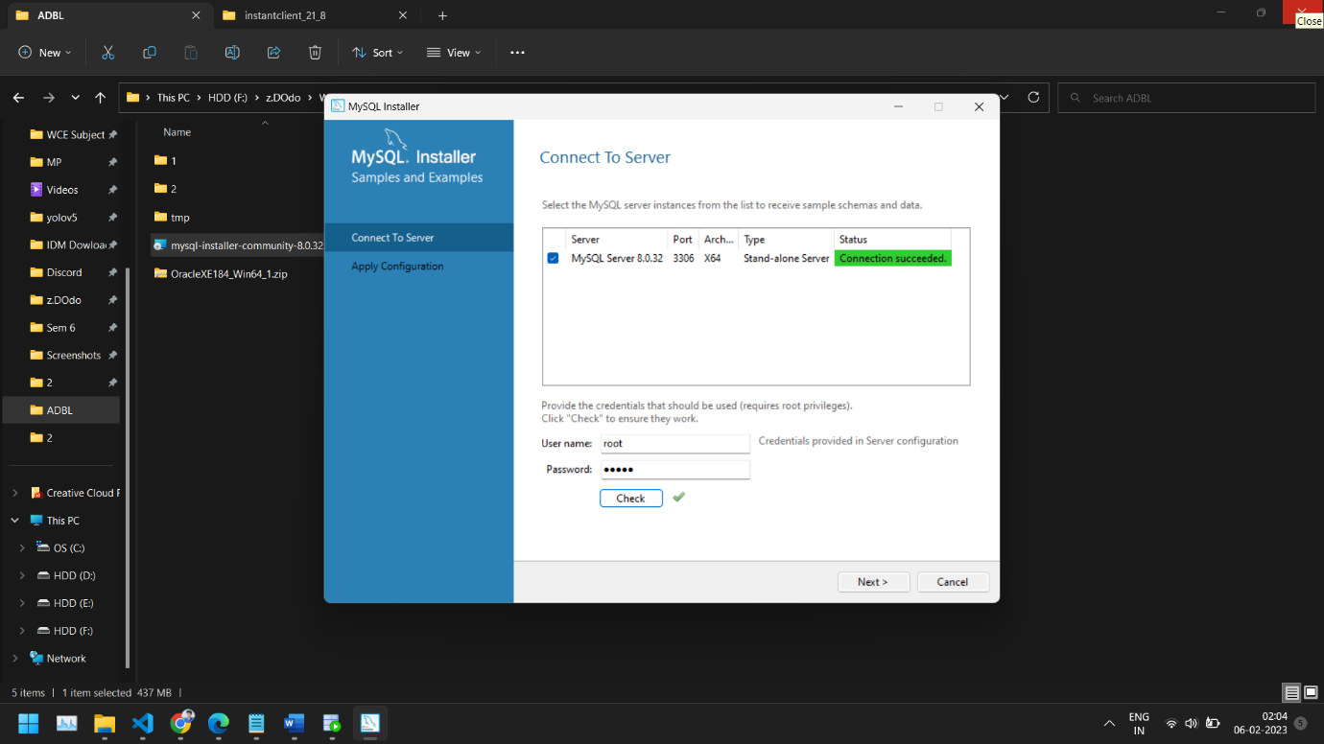

**10) Apply the configuration by clicking on execute. Wait for**

**all changes to be applied. MySQL is installed successfully.**

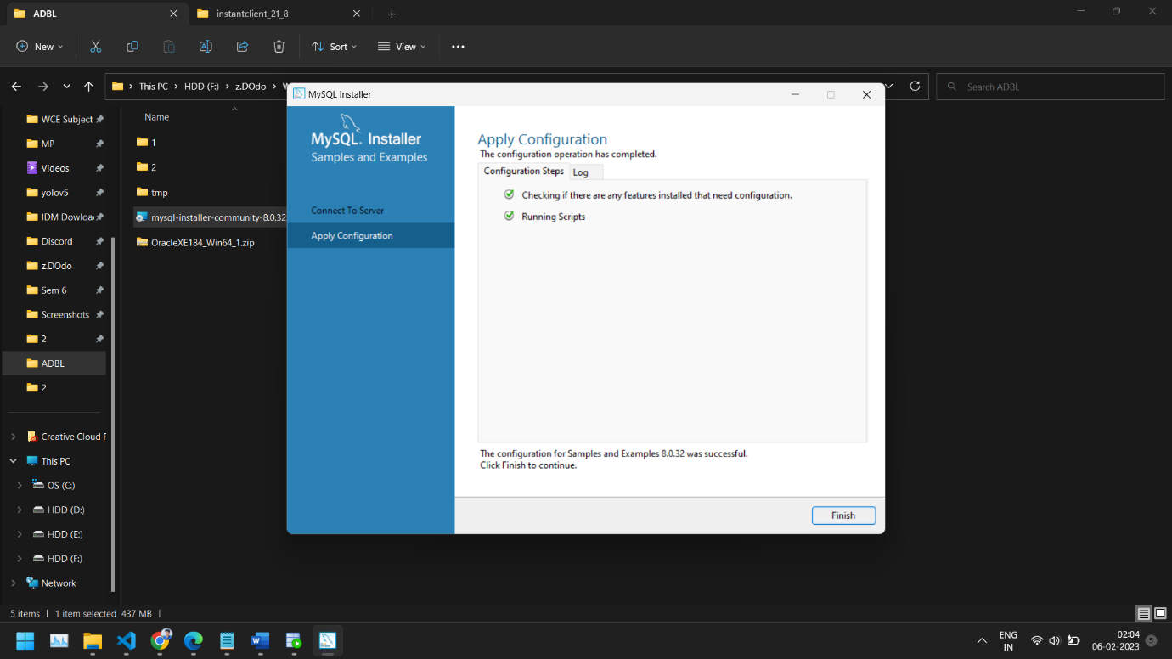

**MASTER NODE :**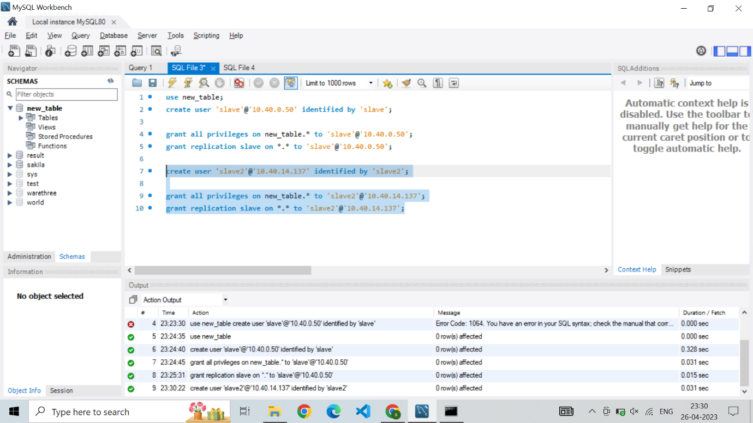

**SLAVE 1:**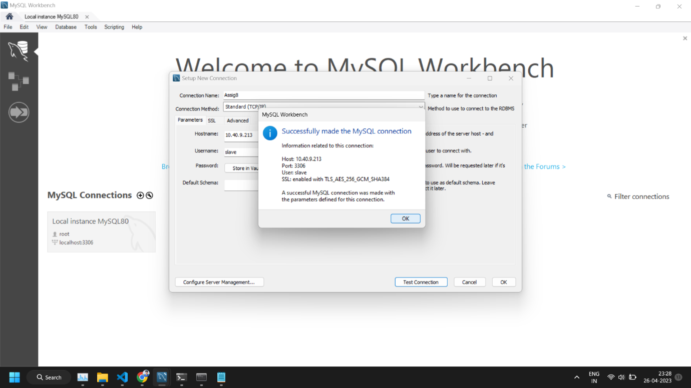

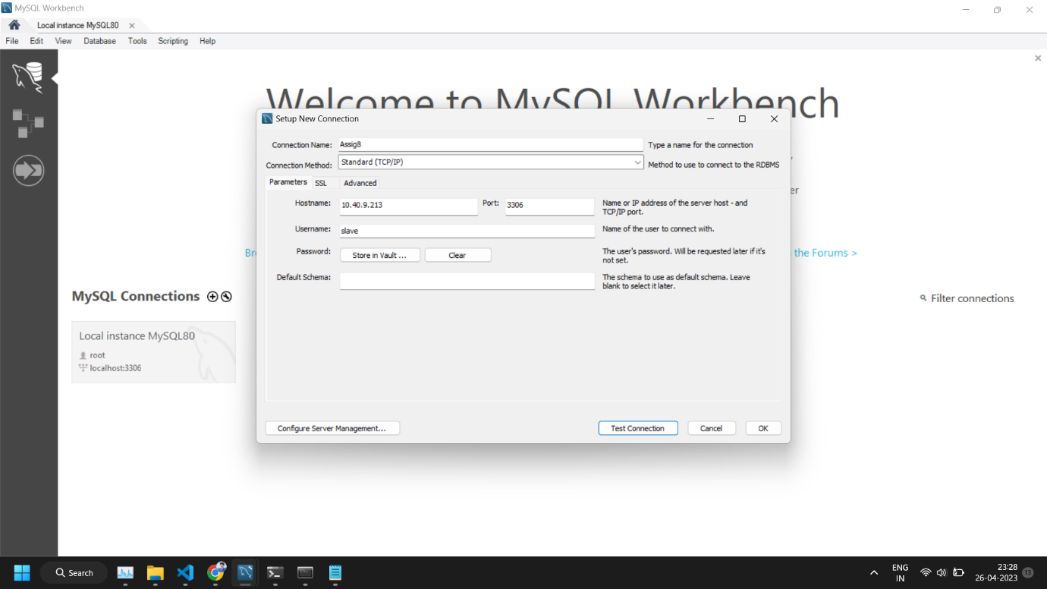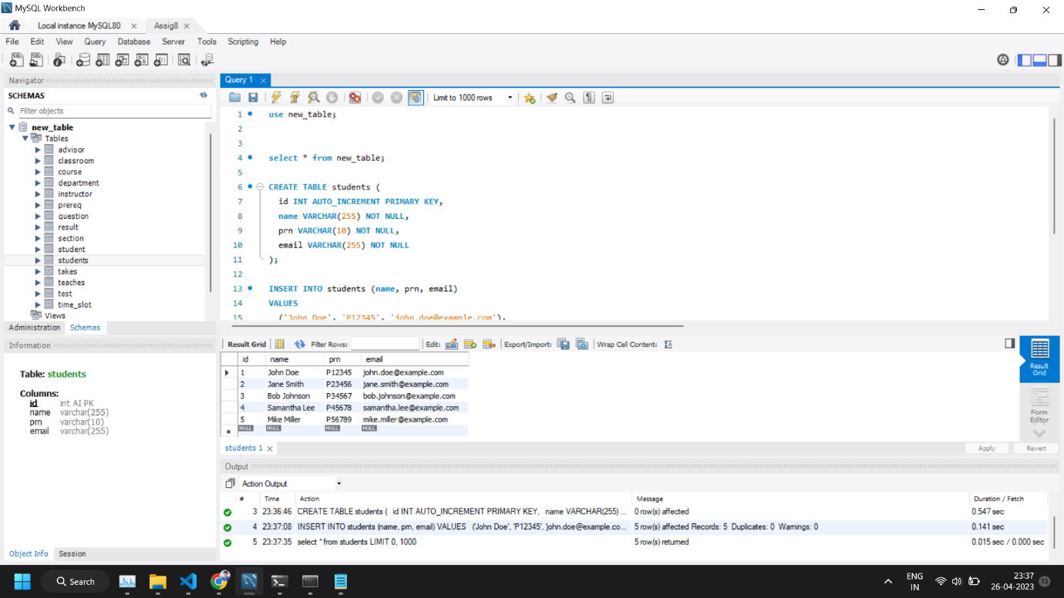 **SLAVE 2:**

